**WOODLAND PARISH COUNCIL**

**Woodland Village Hall**

**Thursday 5 December 2024**

**7:30pm**

**AGENDA**

**1. Apologies**

**2. Declaration of Interest**

**(Members are asked to consider if they have a conflict of interest either personally or pecuniary in any matter included within the agenda)**

**3. Public discussion regarding planning application for Hamsterley Forest development - Planning Application Reference Number DM/24/02979/FPA**

**(Views of the public will be welcome to allow the Parish Council to decide on a response to the proposed development).**

**Each member of the public who wishes to speak will only do so as indicated by the Chair. All comments are to be made through the Chair, with only one person permitted to speak at a time. To allow everyone who wishes the opportunity to make their views known, the Chair may place a limit on the time each person is permitted to speak.**

**Following this public participation, Councillors will then decide what action to take regarding the planning application**

**Date of next Parish Council meeting (Provisional) 9th January 2025**

**Minutes for all Parish Council meetings are available for public viewing on the council website www.woodlandparishcouncil.gov.uk or by contacting the clerk. The minutes will normally be available 4 weeks after the date of the meeting.**

***Please note all Parish Council meetings will be audio-recorded for the purpose of accurately producing the minutes. The recording will be retained by the clerk until the minutes of the meeting have been agreed and signed. The recording will be deleted following the meeting unless retention is requested by a lawful authority.***

**Signed:** 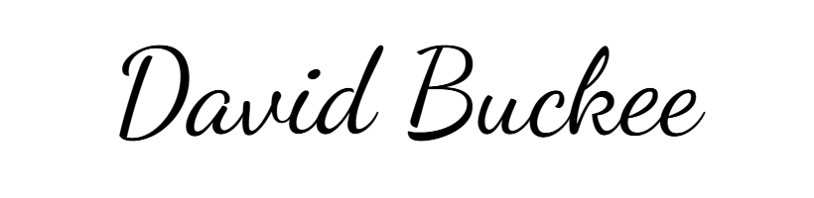

**Date: 2 December 2024**